BLACK HILLS FLOWER DESIGNERS
&
FRIENDLY NEIGHBOR GARDEN CLUB
Presents
“UNDER THE SEA”
Friday, April 17, 2026
12:30 – 2pm
An NGC Standard Flower Show

Thurston County Fairgrounds
Sokolik Building
3054 Carpenter Rd SE
Lacey WA 98503
360-786-5453

Admission is free and open to the public
Member of
Black Hills District
Washington State Federation of Garden Clubs
Pacific Region Garden Clubs, Inc.
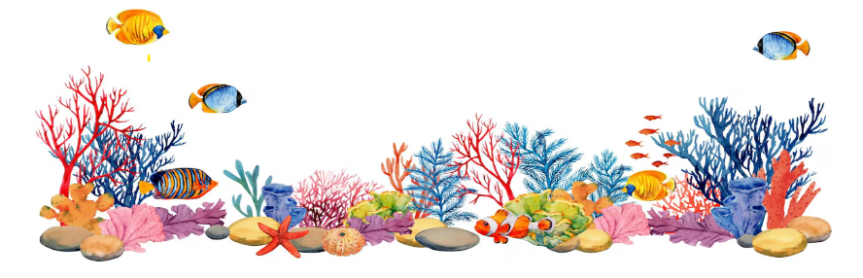
*National Garden Clubs, Inc.

1
Table of Contents

Title Page . . . . . . . . . . . . . . . . . . . Page 1
Table of Contents . . . . . . . . . . . . . Page 2
Show Committee . . . . . . . . . . . . . . Page 3
General Rules . . . . . . . . . . . . . . . . .Page 4 & 5
Awards . . . . . . . . . . . . . . . . . . . . . Page 6
Division Awards . . . . . . . . . . . . .. . .Page 7 -9
Horticulture Rules . . . . . . . . . .. . . . Page 10-11
Division I Horticulture . . . . . . . . . . Page 12-14
Design Rules . . . . . . . . . . . . . . . . . Page 15
Glossary …………………………..Page 16
Division II Design. . . . . . . . . . . . . Page 16-17
Educational Rules . . . . . . . . . . .. . .Page 18
Division III Education . . . . . .. . . . .Page 19
Botanical Arts Rules . . . . . . . .. . . . Page 19
Division IV Botanical Arts . . . . .. ...Page 20
Show Summary . . . . . . . . . . . . .. . . Page 21
Scale of Points ………………...…..Page 22-24
Notes . . . . . . . . . . . . . . . . . . ... . . . ..Page 25

2
Committee Chairmen
Show Co-Chairmen: Linda Maida 253-389-2114
LeAnna McMahan 360-520-2045

Schedule Chairmen: Debbie Spiller 206-755-3616

Staging Chairmen: Debbie Spiller 206-755-3616
Consultants:

Design – Judy Swortz 253-359-4285
Section A-Peggy Starr 360-391-5267
Section B-Suzann Stahl 360-791-7422
Section C-Dorothy Bertram 360-259-2630
Education – Brenda Wood 360-983-3476
Horticulture – Anne Stedham 360-304-8491
Botanical Arts
Artistic Crafts-Brenda Wood 360-983-3476
Photography-Diane Harper 360-498-5188

Placement: Jeff Johnson 760-413-2784
Classification, Design: Judy Swortz 253-359-4285
Judges Chairmen: Vicki Kammerer 360-791-3117

Clerks Chairmen: Sharon McKissick 360-556-5571
Awards Chairmen: JoAnne Sandell 206-291-6195

Publicity: Peggy Starr 360-391-5267

Hospitality: Sandra Zacher 360-496-8472
Photographer: Marty Fortin 360-497-4962

Book of Evidence: LeAnna McMahan 360-520-2045
Dismantling: BHFD & FNGC
3

General Rules
Show Theme: “Under the Sea”
Show Colors: Blue, Green & Turquoise
This Flower Show conforms to the standards established by National Garden Clubs, Inc. (NGC). The Handbook for Flower Shows (HB) 2025 Edition, with revisions printed in the National Gardener Magazine,

Eligibility: Any member of Black Hills District and any Student Judge needing exhibiting credits may enter Division I Horticulture, Division II Design, or Division V Botanical Arts.

Advanced Entries: Advanced entries in Division I, Section E & F, Division II Design or Division IV Botanical Arts Section A & B. Notify listed consultants by April 10, 2026, email and phones are listed.

Entry Time: Enter all divisions between 8:00 and 9:30 am
Friday, April 17, 2026, at Thurston County Fairgrounds, Sokolik Bldg.

Removal Time: Exhibits may not to be removed before 2pm, but must be removed by 3:00pm on Friday, April 17, 2026.

Judging Time: Judging will begin at 10:00 am.

Entry Tags: Entry tags are available online at Black Hills District website also available at the door. Cards are to be filled out in advance if possible, using pencil. Refer to the Handbook for Flower Shows, Chapter 6 for correctly filled out entry tags.

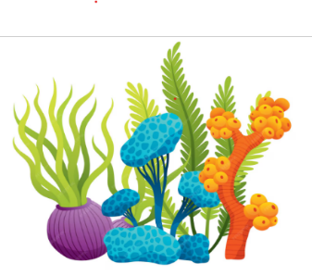

4

Judging Standards:

The Classification Chairmen for each division checks exhibits for conformity to the schedule prior to judging. Final determination or conformance is the judges’ responsibility.

The General Chairmen and the Classification Chairmen for each division are available during judging for possible consultations. They along with the judges and clerks are the only personnel allowed on the floor during judging.

The decisions of the judges are final. Awards may be withheld if not merited.

There must be an emphasis on FRESH plant material. No artificial plant material is permitted in any exhibit in any divisions.

Each exhibitor is limited to one entry per class, except in the Horticulture Division.

The Black Hills Flower Designers and Friendly Neighbors GC will strive to assure the safety of all items after arrival and placement but is not responsible for any loss or damage to exhibits.

Plants on the state conservation list must have been grown by the exhibitor or obtained in a legal manner and so stated. Plants listed
as schedule A noxious weed per web site www.Thurstoncountyweedboard.org will not be allowed.
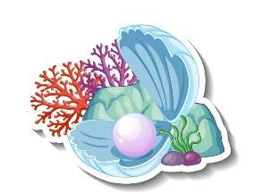

5
Awards

NGC Standard System of Awarding: Is used in all divisions

Scales of points are based on perfection (100 points). Each exhibit is evaluated individually. Exhibits are ranked by the points they receive. Scales of Points for all divisions are stated in Chapter 14 of the Handbook for Flower Shows. Ribbons may be offered in the Flower Show but should be uniformly used throughout all divisions. Award must be withheld if the exhibit does not meet the point value for the ribbon.

A. Only one (1) first – place (blue) ribbon per class or sub-class;
must score 90 or more.
B. Only one (1) second – place (red) ribbon per class or sub-class;
must score 85 or more.
C. Only one (1) third – place (yellow) ribbon per class or sub-class;
must score 80 or more.
D. Only one (1) or more honorable mention (white) ribbons as
merited; must score 75 points or more.

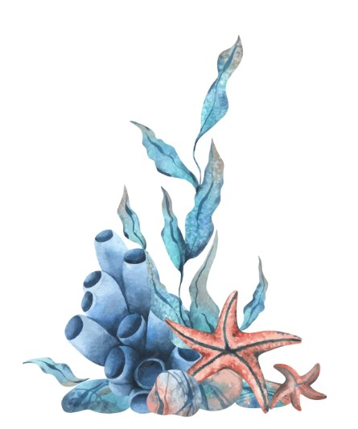

6
Division I Horticulture Awards

NGC Top Exhibitor Awards
Award of Horticulture Excellence: One award may be offered in Sections A – G to a properly named exhibit judged the highest entered in the entire Horticulture Division. Refer to the Handbook for Flower Shows page 40. This award is represented by a rosette of green, blue and orange ribbons. No minimum number of exhibits is required per class.

Award of Merit: One award may be offered in Sections A, B, D & G to an exhibit properly named and scoring the highest blue ribbon ( 95) in that section. Refer to the Handbook for Flower Shows page 41. This award is represented by a rosette of orange ribbons. No minimum number of exhibits is required per class.

Collector’s Showcase Award: Offered in Sections E & F to the highest scoring blue ribbon (95 or over). Refer to the Handbook for Flower Shows page 41. This award is represented by a rosette of dark green ribbons. No minimum number of exhibits is required per class.

WSFGC Awards
Betty Belcher Horticulture Award: Offered in Section A-G to a properly named exhibit judged to be the finest in the entire division. This award is represented by a rosette of green and brown ribbons. No minimum number of exhibits is required per class.

Marva Lee Peterschick Arboreal Flowering Shrub/Tree:
Offered in Section C to a properly named exhibit scoring the highest
blue ribbon. This award is represented by a rosette of green ribbons. No minimum number of exhibits is required per class.

7

Division II Design Awards
NGC Top Exhibitor Award
Award of Design Excellence: Division award offered to the highest scoring, 95 or more blue ribbon exhibit in the entire Design Division entered by an individual. Rosette of gold ribbons.
Designer's Choice Award: Section award offered in Section C. Plant material used in the exhibit may be dried, treated dried and/or fresh. Exhibitors have freedom to choose other components within NGC policies. Rosette of purple ribbons.
Table Artistry Award: Section award offered in Section B. Rosette of burgundy ribbons.
Petite Award: Section award offered for Section A. Rosette of blue and white.
WSFGC Awards
Ellen B. Swenson Flower Arrangement Award: Division award offered to the most outstanding arrangement in Division II. Design must score 95 or above and be selected from the Top Exhibitor Awards. Nominee may apply for the award by submitting a Book of Evidence to the WSFGC Past President’s Awards Chairman by February 1, 2027. Rosette of turquoise ribbons.
Phyllis Danielson Table Setting Award: Section award offered to the most outstanding table setting in Section B. Exhibit must score 95 or more.
Judith Juno Petite Design Award: Section award to the highest scoring Petite Design in a NGC Standard Flower Show is eligible. Nominee may apply for the award by submitting a Book of Evidence to the WSFGC Past President’s Awards Chairman by February 1, 2027. Rosette of emerald green and pale peach ribbons.

8
Recycling Awards: Awarded to exhibits in a flower show that display the best use of recycled items in the creation of beauty and/or originality. Nominee must submit WSFGC Award Application Form (GA #128, revised 2025). List all materials used. Exhibitor must request a green recycling card from Classification, fill it out and attach it to the exhibit. Must score 90 or above. Rosette of blue and green ribbons.

Division III Education Awards
NGC Top Exhibitor Awards
HB pg 39

NGC Educational Award: Division award offered in Division III to highest scoring exhibit. Must score 95 or more and cover a minimum of 18 square feet. Rosette of brown and white ribbons.

WSFGC Award
Carol Klingberg Educational Award: Offered in Division III to the highest scoring educational exhibit. This award is represented by a rosette of yellow ribbons. A minimum of 2 exhibits must be present.

Division IV Botanical Arts Award
NGC Top Exhibitor Awards
NGC Botanical Arts Artistic Craft Award:
Section Award for top exhibitor in Section A. Exhibit must contain some plant material and score 95 or more. Exhibit must be functional. Rosette of navy ribbons.

9

WSFGC Awards
JoAnn Goldman Artistic Craft Award: Award of excellence offered in Section A. Nominee may apply for the award by submitting a Book of Evidence to the WSFGC Past President’s
Awards Chairman by February 1, 2027. Rosette of lavender and purple ribbons.

Terry Critchlow Photography Award: Offered in Section B to the highest scoring blue ribbon. This award is represented by a rosette of blue ribbons. Must have 3 classes with 4 exhibits.

Horticulture Rules and Classes
A. The NGC Exhibit Policies are printed in the Handbook for Flower Shows, Chapter 6, Exhibiting in the Horticulture Division.

B. The rules for a single species cut or container-grown specimen
are listed in the Handbook for Flower Shows or its supplement
Horticulture Exhibiting and Judging.

C. To receive an NGC Top Exhibitor Award, the exhibitor must identify her/his entry by its binomial name or currently acceptable scientific designation.

D. Entry cards are to be filled out in advance if possible. Entry cards to be filled out using pencil. Refer to the Handbook for Flower Shows, Chapter 6 for correctly filled out entry tag.

E. Cut specimens should not have foliage below the water line.

F. If a plant is considered a flowering plant, it should be exhibited
as a flowering specimen. Foliage plants may flower but should be exhibited as foliage plants if they are grown for their leaves.

G. Specimens with a class designation in the schedule may not be
entered in the ‘Any Other Worthy Specimen’ class.

10

H. The Horticulture Classification Committee Chairmen and/or
General Show Chairmen are free to subdivide classes by color,
form size, cultivar, variety or other distinguishing characteristics.

Sections E & F. Collections & Displays are a minimum of five different species exhibited in individual containers or the appearance of being individually exhibited. They may be cut specimens or potted. The Scales of Points for Horticulture are located in Chapter 14 of the Handbook for Flower Shows.

Additional Rules
a. Exhibitor to provide clean, transparent containers of suitable size.
b. Exhibitor may use unobtrusive wedging; plastic wrap is allowed.
c. Double potting allowed.
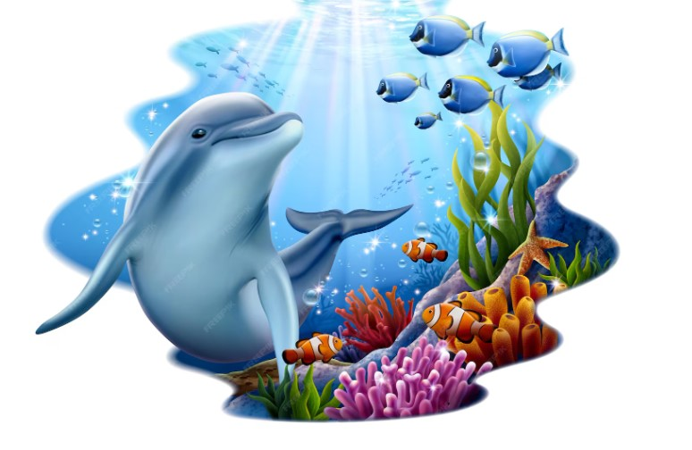

11
Division I Horticulture “Gardens of the Sea”
Section A eligible for NGC Award of Horticulture Excellence,
NGC Award of Merit and Betty Belcher Horticulture Award
Consultant: Anne Stedham 360-304-8491 anntat@me.com

Section A. “Kelp” Bulbs, corms, tubers & rhizomes
2” 1 stem; under 2” 3 stems
Class 1. Hyacinth
- Single
- Double
- Multi-flora
Class 2. Iris
- Bearded
- Siberian
- Dutch
- Japanese
Class 3. Lily
- Asiatic
- Oriental
- Trumpet
Class 4. Miniature perennials
- Galanthus (snowdrops
- Hosta
- ‘Tete a Tete’ Daffodil
- Tulipa
Class 5. Narcissus
- Daffodil
i. short cup
ii. long cup
- Jonquil
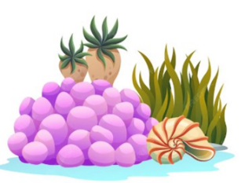
- Trumpet

12

Class 6. Peony.
- Herbaceous
- Itoh
- Tree
Class 7. Tulipa
- Double
- Fringed
- Hybrid
- Single
Class 8. Any other bulb, corm, tuber or rhizome

Section B eligible for NGC Award of Horticulture Excellence,
NGC Award of Merit and Betty Belcher Horticulture Award

Section B. “Anemone” Flowering Perennials
2” 1 stem, over 2” 3 stems
Class 9. Columbine
Class 10. Epimedium
Class 11. Euphorbia
Class 12. Geranium
Class 13. Hellebores
Class 14. Viola
Class 15. Any other worthy named flowering perennial.

Section C. eligible for NGC Award of Horticulture Excellence, Betty Belcher Horticulture Award and Mara Lee Peterschick Flowering Shrub/Tree Award

Section C. “Mangrove” Flowering Shrubs in Bloom
Class 16. Camellia
Class 17. Lilac
Class 18. Pieris japonica
Class 19. Rhododendron, exhibited with 1 truss with attached foliage
Class 20. Viburnum
Class 21. Any other worthy named flowering shrub

13
Section D is eligible for NGC Award of Horticulture Excellence, NGC Award of Merit, NGC Arboreal Award and Betty Belcher Horticulture Award.

Section D. “Fucus” Non-Flowering shrubs
Class 22. Boxwood
Class 23. Euonymus
Class 24. Juniper
Class 25. Ilex crenata ‘Japanese holly’
Class 26. Laurus nobillis ‘Laurel’
Class 27. Nandina
Class 28. Any other worthy non-flowering shrub

Sections E and F eligible for NGC Award of Horticulture Excellence and the NGC Collector’s Showcase

Section E. “Sea Cucumbers” Collections
An exhibit of specimens (5 or more) judged for their cultural perfection.
Advance registration required to Judy Swortz 253-359-4285
by April 10, 2026.
Class 29. Flowering
Class 30. Foliage
Class 31. Succulent

Section F. “Plantain” Displays
A collection of specimens exhibited with a strong overall artistic effect.
Advance registration required to Judy Swortz, 253-359-4285
by April 10, 2026.
Class 32. Flowering
Class 33. Foliage
Class 34. Succulent 14

Section G “Sea Grass”
Class 35. Any other worthy named specimen not listed in this
Schedule. Classes may be formed as entries require.

Design Rules and Classes
A. The NGC Exhibit Policies are printed in the Handbook for Flower Shows, Chapter 7, Exhibiting in the design division, NGC Policies and Guidelines.

B. Advance registration with the design Entry Chairman Consultant is required by April 10, 2026.

C. Plant material and non-plant material permitted and not permitted in the design division are printed in the Handbook for Flower Shows, Chapter 7.

D. All plant material used in the design must be identified on a card, provided by the exhibitor, and included with the entry tag.

E. The exhibitor is required to conform to the stated description and limitations of the Design Type if named in the class.

F. Rules for Design Types, Advanced Design Types, Table Designs and Table Appointments are printed in the Handbook for Flower Shows, Chapter 7.

G. Designer is on her/his honor that the design being entered has not been previously entered or judged in an NGC Standard Flower Show.

H. The Scale of Points for Design is listed in the Handbook for Flower Shows, Chapter 14.

15
Design Glossary
Buffet Table: service for four (4) or more, with components conveniently and logically placed for ease of self-service. At least one (1) serving piece required. A decorative unit must be included. (HB 76).
Decorative Unit: A complete floral Design.
Designer’s Choice: A design in which the designer chooses whether the
plant material will be all fresh, all dried plant material, or a combination of both, plus other components.
Exhibition Table: An artistic arrangement of table components, within an allotted space, to provide a creative effect without consideration for functional placement. Plant material must be used as needed for the overall design. (HB 76)
Hanging Design: A suspended design to be judged at a comfortable viewing height.
Transparency Design: A creative design with see-through elements (translucent, grid-like, diaphanous materials etc.) integral to the design and permitting some components to be viewed through others.
Tray for one: decorative unit should be in scale with the place setting. The tray requires an appropriate -sized decorative unit with the stability of the decorative unit given importance.

Underwater Design: A creative design having components including some or all plant material, submerged in water to create interest.

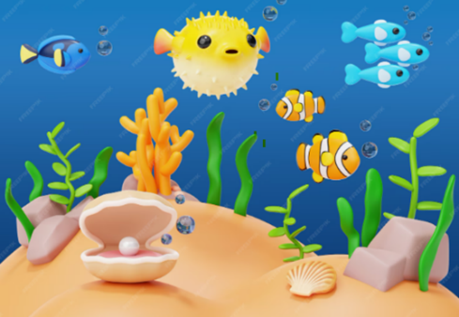

16
Division II Design “The Deep Blue Sea”

Consultant: Judy Swortz: 253-359-4285 judyswortz@comcast.net

Section A. eligible for NGC Petite Award, NGC Award of Excellence; WSFGC Judith Juno Petite Design Award; and WSFGC Ellen Swenson Flower Arrangement Award, WSFGC Recycling Award

Section A. “Tiny Bubbles” Petite Designs
Consultant: Peggy Starr 360-391-5267

Class 1. “Sea Horse”- Designer’s choice of design type. Not to exceed 5" in height, width or depth. Staged on 4” square black marbleized blocks provided by show committee on a table draped in black.

Class 2. “Little Mermaid” - Designer's choice of design type. Not to exceed 8" in height, width or depth. Staged on acrylic risers 4” deep x 6” wide of varying heights on a table draped in black.
Class 3. “Clownfish”– Designer’s choice of design type. Not to exceed 12" in height, width or depth. Staged on 18"x18" of an 8' table draped in black.
Sections B eligible for NGC Table Artistry Award, NGC Award of Excellence; WSFGC Phyllis Danielson Table Setting Award; Ellen Swenson Flower Arrangement Award, WSFGC Recycling Award

Section B. “Bounty of the Sea” Table Settings
Consultant: Suzann Stahl 360-791-7422
Class 4. “Crab Pot”-Exhibition table setting for cocktails, to be staged on a pedestal that is 36” tall with a 20” round top. Must contain some plant material, to be viewed from all sides.

Class 5. “Cioppino”-A Buffet Table for (4) staged on a 6’ table draped in black. Additional table coverings to be provided by the exhibitor. Must contain a decorative unit, to be viewed from all sides.
17

Class 6. “Fish & Chips”-Functional tray maximum 20” in length setting for (1) for lunch staged on 24” x 30” of an 8’ table draped in black. Must contain a decorative unit.
Section C. eligible for NGC Designer’s Choice Award; NGC Award of Design Excellence, WSFGC Ellen B. Swenson Flower Award, WSFGC Recycling Award
Section C. “Treasures 0f the Deep” Designers Choice
Consultant: Dorothy Bertram 360-259-2630
Class 7. “Yellow Submarine” Underwater design. staged on 24” of 6’ table. draped in black. Staging panel allowed.
Class 8. “Shipwreck” Free Hanging design to be staged in Black frame 72” high, 36” wide. Frame is on the floor.
Class 9. “Coral Reef” Transparency design to be staged on 24” x 30” of a 6’ table draped in black. Staging panel allowed.
Division III Education “Seascape”
Educational Rules and Exhibits
1. Exhibit to cover a minimum of 18 square feet.
2. Use of some fresh plant material is recommended but not required. Artificial plant material is not allowed.
3. Staged on a 6’ by 30” table, skirted in black, provided by the committee.
4. Handouts are encouraged, not required.
5. Educational exhibits may be the work of more than one individual or organization unless a student judge or an accredited judge is seeking exhibiting credit for preparing an educational exhibit. These are competitive exhibits.
6. The table will be skirted in black.

18
Eligible for NGC Educational Award and WSFGC Carol Klingberg Award, WSFGC Recycling Award
Consultant: Linda Maida 253-389-2114
Exhibit 1. Items We Don’t Want Under the Sea
Exhibit 2. Harvests From the Sea

Botanical Arts Rules and Classes
A. All botanical arts horticulture, design and artistic craft exhibits
must contain some plant material.

B. No artificial plant material is permitted in any exhibit.

C. The scale of points for judging botanical arts horticulture, design artistic crafts and photography are listed in Chapter 14 of the Handbook for Flower Shows.

D. The rules for botanical arts horticulture are printed in the Handbook for Flower Shows, Chapter 10.

E. The general guidelines for all designs as printed in Chapter 10 of the Handbook for Flower Shows, including a card provided by the exhibitor listing plant material used in the design apply.

F. The rules for botanical artistic crafts are printed in the Handbook for Flower Shows, Chapter 10.

G. The rules for photography are printed in the Handbook for Flower Shows, Chapter 10.
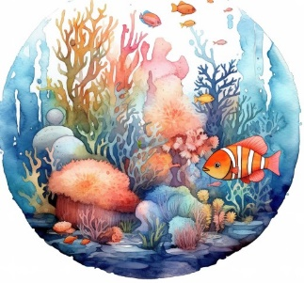

19

H. All photographs to be displayed on an 8”x10” black mat with a
non-glossy finish (matte) provided by the exhibitor.

I. All photographs are to be 5”x7”. The portrait mount will have the 5” measurement on the top, the landscape mount will have the 7” measurement on top.

Division IV Botanical Arts “Beauty of the Sea”

Section A eligible for NGC Botanical Arts Artistic Craft Award and WSFGC JoAnn Goldman Award, WSFGC Recycling Award
Section A. “Creatures from the Deep” Artistic Crafts
Consultant: Brenda Wood 360-983-3476
Class 1. “Sea Creature” A sea creature created entirely from recycled materials to be staged on 18”x 18” of a 8’x 30” table draped in black.
Class 2. “Mermaid’s Tiara” A tiara of reasonable size to fit on a Styrofoam head form furnished by show committee.
Class 3. “Sea Jewels” A women’s brooch not to exceed 4” in any direction, to be displayed vertically on a black velvet standing form.
Section B. is eligible for Terry Critchlow Photography Award

Section B. “Beyond the Sea” Photography
Consultant: Diane Harper 360-498-5188
Photos are to be 5” x7” matted by exhibitor. They may either landscape or portrait mount. All staging provided by committee.

Class 4. “Ocean Sunset”
Class 5. “Sea Animals”
Class 6. “Birds of the Sea”
20

SHow Summary

Division I – Horticulture ______________________

Division II – Design __________________________

Division III – Educational ____________________

Division IV – Botanical Arts

Horticulture _________________________

Artistic Crafts________________________

Photography ________________________

21

SCALES OF POINTS

- All Cut or Container-Grown Horticulture Specimens and Collections
(Arboreal, Flowering, Foliage, Fruit/Vegetable/Nuts)
Criteria | Value
Conformance | 5
Plant Identification | 5
Peak of Perfection
Form | 20
Color | 20
Maturity/Size | 20
Condition/Blemishes | 15
Grooming/Staging
Grooming | 10
Staging | 5
TOTAL | 100

- Combination Plantings and Gardens
Criteria | Value
Conformance | 5
Plant Identification | 5
Labeling | 5
Peak of Perfection
Form | 10
Color | 10
Condition | 10
Show-worthy size | 5
Overall effect | 30
Creative/Distinctive | 5
Grooming | 10
Staging | 5
TOTAL | 100

22
- Displays

Criteria | Value
Conformance | 5
Plant Identification | 5
Labeling | 5
Grooming | 5
Peak of Perfection
Form | 10
Color | 10
Maturity/Size | 10
Condition | 10
Design Principles | 30
Creative/Distinctive | 10
TOTAL | 100
- All Designs

Criteria | Value
Conformance
To type | 7
To schedule requirements | 7
Design Principles | 48
Selection of Components | 8
Organization of Components | 8
Expression | 8
Distinction | 14
TOTAL | 100
- Educational Exhibits
Criteria | Value
Educational value
Interest to viewer | 25
Clear, concise presentation | 15
Adequate signage | 10
Conforms to NGC objectives | 10
Staging
Craftsmanship/Technique | 10
Distinction | 10
Creativity and Expression | 20
TOTAL | 100
23
- Artistic Crafts

Criteria | Value
Conformance | 25
Design | 30
Craftsmanship/Technique | 25
Distinction | 20
TOTAL | 100

- Photography
Criteria | Value
Conformance | 5
Interpretation of Class Title | 10
Composition | 25
Artistry/Creativity | 25
Technical Achievement | 25
Distinction/Impact (WOW factor) | 10
TOTAL | 100

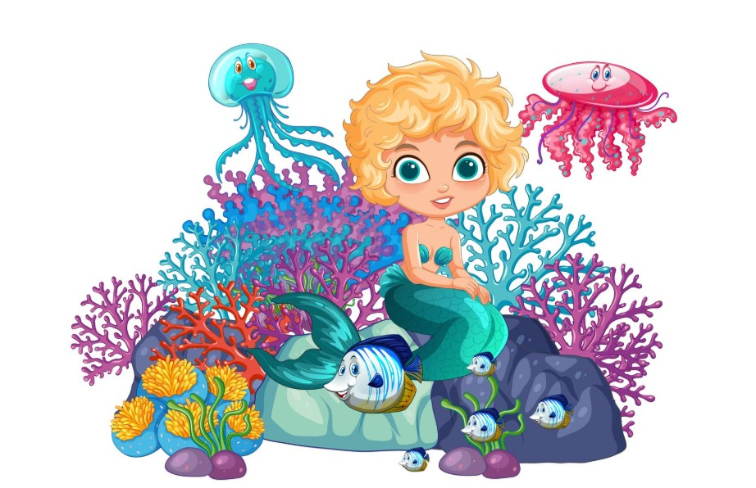

24
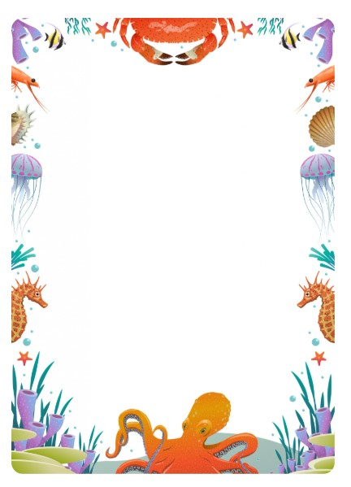
NOTES

