

The 2026 Revolutionary Gardens Tour

THURSDAY, APRIL 23 – As check-in time is 4 p.m. at our “home away from home” for the tour, the Hampton Inn Richmond-Midtown, please schedule your flight into Richmond International Airport to arrive after 1 p.m. Your tour managers – Teresa Watkins and Tony
DeSormier – will be on hand to greet you and make sure you get settled in. At 5:30 p.m., we will convene in the evening for an included dinner.
(Reception, D) Overnight: Hampton Inn Richmond-Midtown.
10800 W Broad St. Glen Allen, VA.

FRIDAY, APRIL 24 – Since Thursday was spent getting to Virginia, today’s schedule allows you to sleep in a bit. After catching the included breakfast at the bus at 9:30 a.m. to visit two amazing Richmond venues, Maymont and Agecroft Hall and gardens. More an “expression of Gilded Age luxury and opulence,” than Revolutionary horticulture, we were compelled to include these two magnificent architectures to our tour. Maymont is “a private estate joyously opened to the public through the generosity of its owners.” Included will be a Walk Through the Gardens tour led by the Senior Manager of Horticulture and Grounds. “Maymont’s Italian Garden artfully combines the classical elements of
geometric design, varied colors, multiple levels and historic vistas to create a distinctly formal garden experience within the natural setting of the James River fall line terrain.”
After leaving Maymont at 11:30 a.m. and lunch enroute, the afternoon will be spent at Agecroft Hall and Garden, “a 16th century gem in the heart of Central Virginia”.
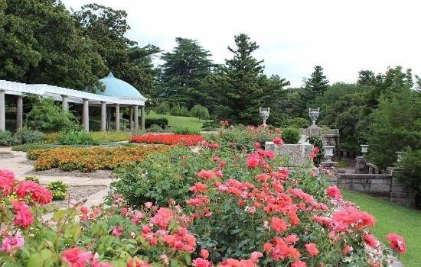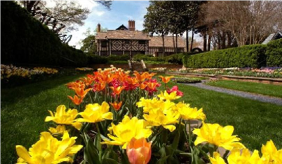
www.agecrofthall.org
Maymont.org

Originally constructed in Lancashire, England in the late 15th and early 16th centuries, Agecroft – structure and interiors – was purchased in 1925 by T.C. and Elizabeth (Bessie) Williams Jr. Guide by architect Henry G. Morse, the most intact portions of the manor were dismantled and shipped across the Atlantic Ocean to Richmond. “Elizabeth lived in the house for 40 years, marrying Dr. David Morton in 1930, and carefully planned the landscape surrounding the manor in partnership with Charles Gillette, the highly regarded landscape architect. Their collaboration resulted in the terraces and sunken garden, inspired by designs at Hampton Court Palace in England. The trails that wind along the river’s edge are a testament to her continued love of outdoor spaces. Dinner that night will be at Tarrant’s Downtown in Richmond’s historic district before returning to the hotel.
(B, D) Overnight: Hampton Inn Richmond-Midtown.

SATURDAY, APRIL 25 – Today will be spent in and around Fredericksburg visiting two properties associated with George Washington. First, enjoy breakfast then board the bus at 9:30 a.m. to go to Historic Kenmore. Completed in 1775, “the Georgian-style brick mansion for George Washington’s sister, Betty Washington Lewis, and her husband ... Fielding Lewis”. After a guided tour of the house, time is allotted for you to explore the grounds on your own.
At noon, board our bus, and after a quick stop for lunch, you are off to the boyhood home/farm of George Washington, Ferry Farm. The guided tour of the Washington house replica explores the lives of George, his mother Mary, other Washington family members, and the enslaved community. It recounts the adversity all these individuals faced after the death of Augustine Washington, George’s father. You can walk Ferry Farm’s grounds before and after your house tour.”
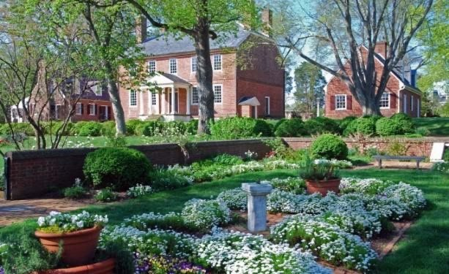
If you’re so inclined, there is also The Science of History at Ferry Farm exhibit of “colonial and Civil War artifacts excavated at Ferry Farm and windows into the Archaeology Lab, where you can see archaeologists identify and study thousands of artifacts found at Ferry Farm.” The day will wrap up with an included dinner at the Colonial Tavern, home to the Irish Brigade of the later Civil War, before heading back to the hotel.
(B, D) Overnight: Hampton Inn Richmond-Midtown.

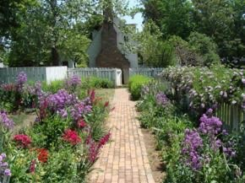

SUNDAY, APRIL 26 – This day will be spent at Colonial Williamsburg. Early breakfast this morning, be ready to board the bus at 9 a.m. The visit will start with a guided tour of the gardens. Kenmore.org

From then on, you have the day to yourself to explore “the world’s largest living history museum, where you can see, hear and touch this influential city as it once was.” Enjoy lunch at any of the more than a dozen venues for food and drink, then continue
exploring your choice of the “89 original 18th-century buildings as well as the hundreds more buildings reconstructed based on historical records and archaeological research.”
At 4:30 p.m., start making your way to enjoy relaxed dining at the Blue Talon Bistro for an included group meal. Then it is back to the hotel to rest after a full day of history and gardens. (B, D) Overnight: Hampton Inn Richmond-Midtown.

MONDAY, APRIL 27 – A lot of today will be spent on the bus to get to two sites rich with Revolutionary Era history. Get breakfast early because at 8 a.m., it is on the bus to Lynchburg to visit the Old City Cemetery. Not only is it the burial site of veterans who served in the Revolutionary War, “The grounds are also filled with hundreds of varieties of native and heirloom plants, including the largest public collection of antique roses in the state of Virginia ... (the) grounds feature over 600 trees and about 121 labeled species.”

A guided tour is planned to make sure you get the most out of the visit. At 11:30 a.m., it is back on the bus where a delicious full boxed lunch will be provided for the 90-minute ride to Thomas Jefferson’s Monticello. A 45-minute Highlights Tour is planned in order to give you ample time to explore the grounds according to your personal interests. “Enjoy Monticello’s gardens and grounds at your own pace. Guests can tour the mountain to and restored South Wing, Mulberry Row, and exhibit spaces under the house. You can also take advantage of the seasonal Garden Tour, daily Slavery at Monticello Tour, and get a picture of the iconic west view.” The day will wrap up with a dinner included at Michie Tavern, ca 1784. This restaurant has been serving travelers with food, drink and lodging for over two hundred years.

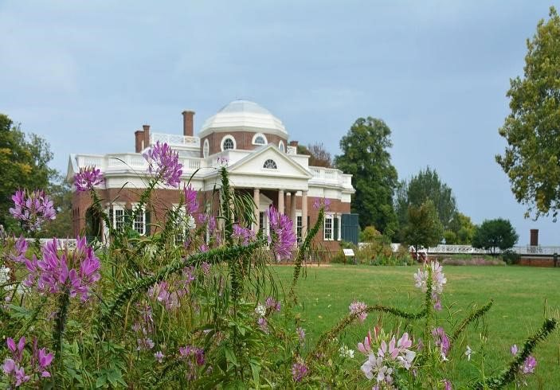
(B, L, D) Overnight: Hampton Inn Richmond-Midtown.

TUESDAY, APRIL 28 – After breakfast, it is another early start – 8 a.m. – to head north toward the District of Columbia and Alexandria. The final full day of the tour begins with a visit to the U.S. Botanic Garden. “The outdoor gardens of the USBG, a dynamic collection of formal and naturalistic gardens, provide visitors with diverse examples of how plants can be used to provide wildlife habitat and ecosystem services while enhancing outdoor spaces, growing food, telling a story, and improving people’s lives. The three-acre gated outdoor gardens draw inspiration from the environments of the MidAtlantic region.”
After a grab-and-go lunch, it is off to George Washington’s Mount Vernon. A tour is planned to provide an overview of the grounds and gardens. You will then be allowed to explore Mount Vernon at your leisure. Perhaps you would like to take time to check out the Upper, Lower, or Botanical gardens or the Fruit Garden and Nursery. You might prefer to enjoy “Mount Vernon's landscape ... George Washington’s carefully composed “pleasure grounds,” the highly cultivated, ornamental grounds created for the enjoyment of his guests.” It is only fitting that the final group meal of the tour be convened at the Mount Vernon Inn.
(B, D) Overnight: Hampton Inn Richmond-Midtown.

WEDNESDAY, APRIL 29 – After our last breakfast and warm goodbyes, we will be splitting up to get back to Richmond International Airport to wing our way home, taking with us the memories of a once-in-250-year experience of gardening, culture, and history.
(B) Overnight: Home


YOUR PACKAGES INCLUDE:
- 6 Nights’ accommodation
- 6 Breakfasts
- 1 Lunch
- 6 Dinners
- Guided Historic Gardens tour at Maymont
- Admission to Agecroft Hall and Garden with guided tour
- Guided tour at Historic Kenmore
- Admission to Ferry Farm
- Admission and guided tour at Colonial Williamsburg
- Guided tour at Lynchburg’s Old City Cemetery
- Admission and guided tour at Monticello

PRICING INFORMATION
• Entry to U.S. Botanical Garden • Admission and guided tour at Mount Vernon
• Services of a full-time tour manager
• Baggage handling for one piece of luggage per traveler
• Private motor coach transportation throughout the tour
• Accommodations, admissions, group meals and baggage service for the coach driver
• Taxes and gratuities for all included meals. (Note: gratuities for the coach driver and tour manager are not included and are at your discretion based on service.)

Pricing Information: The following prices are based on fifteen paid travelers. Fewer than fifteen paid travelers may result in a price increase. Prices and itinerary are subject to change.
Per person double occupancy: 3,325.00
Per person single occupancy: 3,850.00
Pricing includes a $200 donation pp to Olympic Peninsula District of Garden Clubs.
Trip insurance and airfare are not included.

Contact Pam Ehtee, District Director of Olympic Peninsula Garden Club, at pamehtee@gmail.com to request additional information and to reserve your spot. 20 people maximum. $500 deposit required upon registration.

.https://www.artinbloomgardentours.com/tours/need-travel-insurance
ART IN BLOOM GARDEN TOURS LLC is registered with the State of Florida as a Seller of Travel. Registration No. ST45420l.
City of Orlando BUS 1113171

